Department of BCA
Mandatory Disclosures: AICTE Approval Handbook 2024-2027
Name of the Institution:
Mudalgi Education Society’s
Arts and Commerce College Mudalgi
Department of BCA
Gokak-Athani Main Road
Mudalgi-591312
Tq: Mudalagi
Dist.: Belagavi
State: Karnataka
E-Mail:

Name and address of the Trust/Society/Company and the Trustees:

Mudalgi Education Society’s
Gokak-Athani Main Road, Mudalgi-591312, Karnataka

Board of Directors

Name and Address of the Principal
Director: Mahantesh Shankar Kundaragi
Address: Shivapur(H)
Contact-9742886481

Name of the affiliating University
Rani Channamma University
Vidyasangama NH-04 Belgavi-591156

Governance
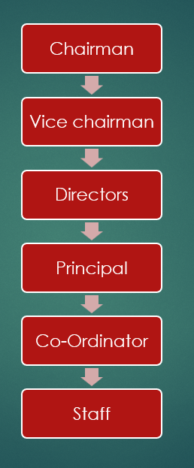

i. Grievance Redressal mechanism for faculty, Staff and students
The college redresses the grievance of the faculty, staff and students. The complaints received (if any) is redressed by the HODs/Principal/Management and corrective measures are immediately implemented

ii. Establishment of Anti-Ragging Committee – Annexure I

iii. Establishment of Internal Committees – Annexure III

iv. Establishment of Committee for SC/ST – Annexure IV

v. Internal Quality Assurance Cell – Annexure V

vi. Equal Opportunities Facilities Cell – Annexure VI

PROGRAMMES
Name of Programs approved by AICTE (202526) UG-Programs

SLNO | Programme | Starting Year | 2025-26
01 | BCA | 2024 | 40

Total number of UG courses:

vii. Fees as approved by the State Government –Annexure VII

viii. Name and duration of Programme(s) having Twinning and Collaboration with Foreign University(s) and being run in the same Campus along with status of their AICTE approval

–Not Applicable

ix. Nature of Collaboration

–Not Applicable

x. Complete details of payment a student has to make to get the full benefit of Collaboration

–Not Applicable
xi. For each Programme Collaborated provide the following

– Not Applicable

xii. Programme Focus

– Not Applicable

xiii. Number of seats

– Not Applicable

xiv. Admission Procedure

– Not Applicable

xv. Fee (as approved by the state government)

– Not Applicable

xvi. Whether the collaboration Programme is approved by AICTE?

– Not Applicable

Faculty:
SLNO | Name | Qualification | Designation
01 | Mahantesh Kundaragi | MCA | Coordinator
02 | Shilpa Kamble | MCA | Lecturer
03 | Nikhita Bharmannavar | MCA | Lecturer
04 | Veda Deshpande | M.Com(Account) | Guest-Lecturer
05 | Girish Kokatanur | M.Sc(Maths) | Guest-Lecturer
06 | A.C. Misinaik | M.A(Kannada) | Lecturer
07 | P.B.Choudaki | M.A(English) | Lecturer
08 | Pavankumar K | M.A (Political) | Lecturer
09 | Prathibha Pandroli | M.Sc(Geo) | Guest-Lecturer

Admission
No. of seats sanctioned with the year of approval UG Programmes
SLNO | Programme | 2025-26 |  | 2024-25
SLNO | Programme | Intake | Add | Intake | Add
01 | BCA | 40 | 14 | 40 | 40

Information of infrastructure and other resources available
That the Land/Built-up area details given below in the Table are true and complete;
Sl. No. District | Name of the deed Holder | Document No. | Date of Registration | Plot No. | Address (Village) | Area in Acre
01 | Chairman  Mudalgi Education Society Mudalgi | MR/568/ 2010-11 | 5/8/2011 | 500/*/* | Mudalagi | 16.35
02 | Chairman  Mudalgi Education Society Mudalgi | MR/568/ 2010-11 | 5/8/2011 | 501/*/* | Mudalagi | 26.28

ADMINISTRATIVE AREA

Room No. | Room type (mention Class Room/Laboratory/Toilet, etc.) | Carpet area (in m2) | Completion of Flooring | Completion of Walls and | Completion of Electrification and lighting
Office | Office All Inclusive | 37 | Ready | Ready | Ready
Principal | Principal Room | 37 | Ready | Ready | Ready

AMENITIES AREA

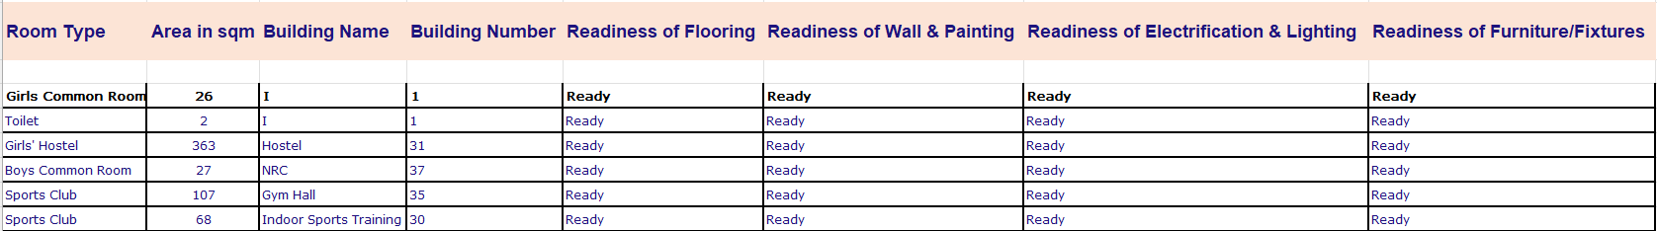

INSTRUCTIONAL AREA

INSTRUCTIONAL AREA- COMMON FACILITIES

i. Barrier Free Built Environment for Disabled and elderly persons Ready The following Infrastructure and other support measures are provided to persons with physical disabilities: 1. Ramps/Rails are available at ground floor.
2. Adequatespaceisprovidedformovementofwheelchairuserstoenterintoclassrooms, laboratories, toilets and other areas within the building.
3. Hand rails for persons who use Crutches with anti-skid(non-slip) floors

- Fire and Safety Certificate
